Here we will be using Tensor flow( open source library to create deep learning end to end projects), the other library is pytorch. learning anything will be enough

and Keras, Keras is a wrapper on the top of tesnsor flow. that provides api’s will less lines of code.

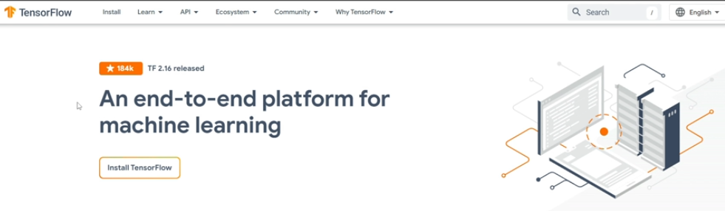

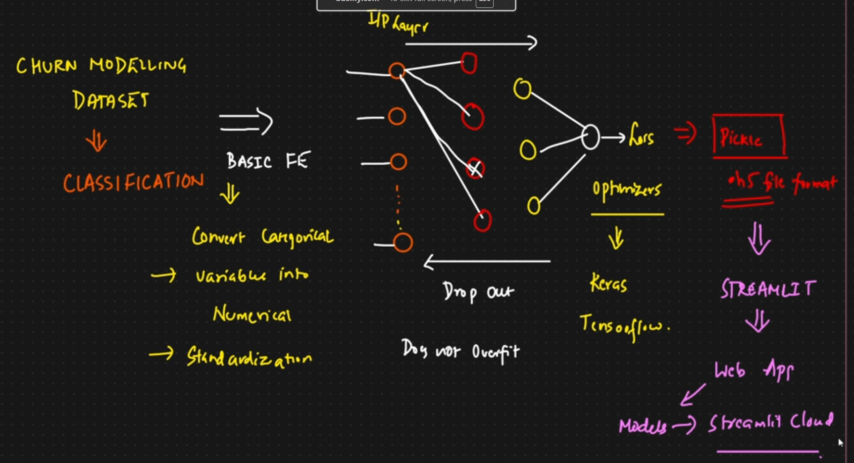

Code to create a Virtual environment in VS code for python
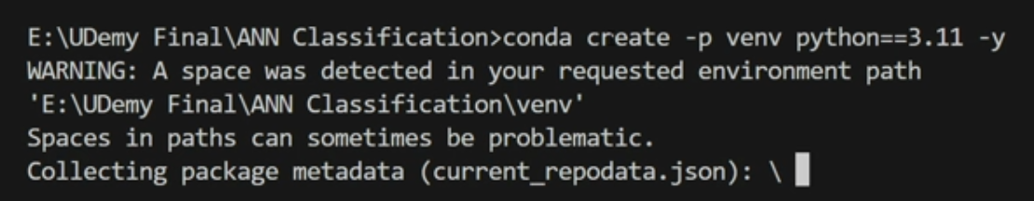
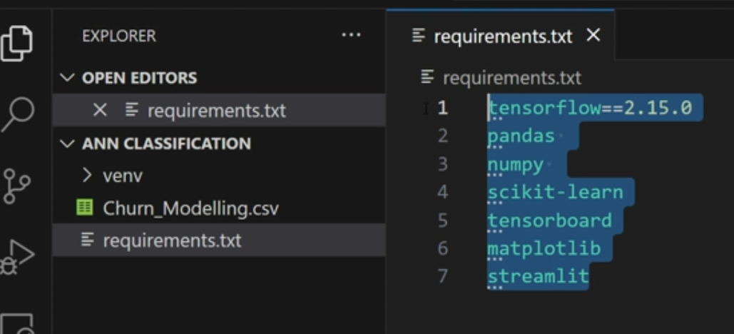
now activate Virtual environment
This will install all the packages

Also install IpykernalThis will help to attach the kernel and execute the jupiter note book file.

Train ANN

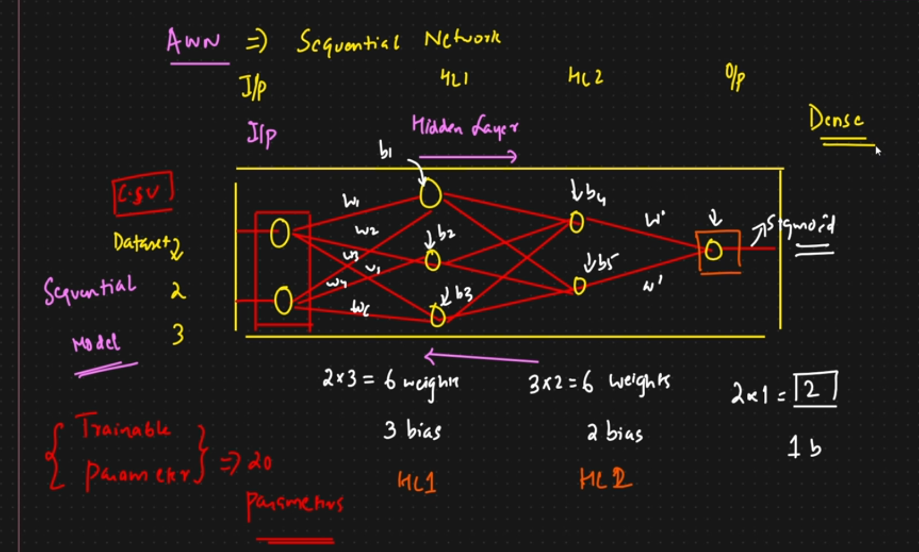

In Keras there is a api called Dense library to create hidden neurons in the model. here we are creating 64 hidden neurons
every neuron can have activation function that are Sigmoid, tanh, Relu, Leaky Relu
optimizer is used to updating the weights
loss function
metrics
training logs will be stored in folder and later use tensor board to visualize the logs
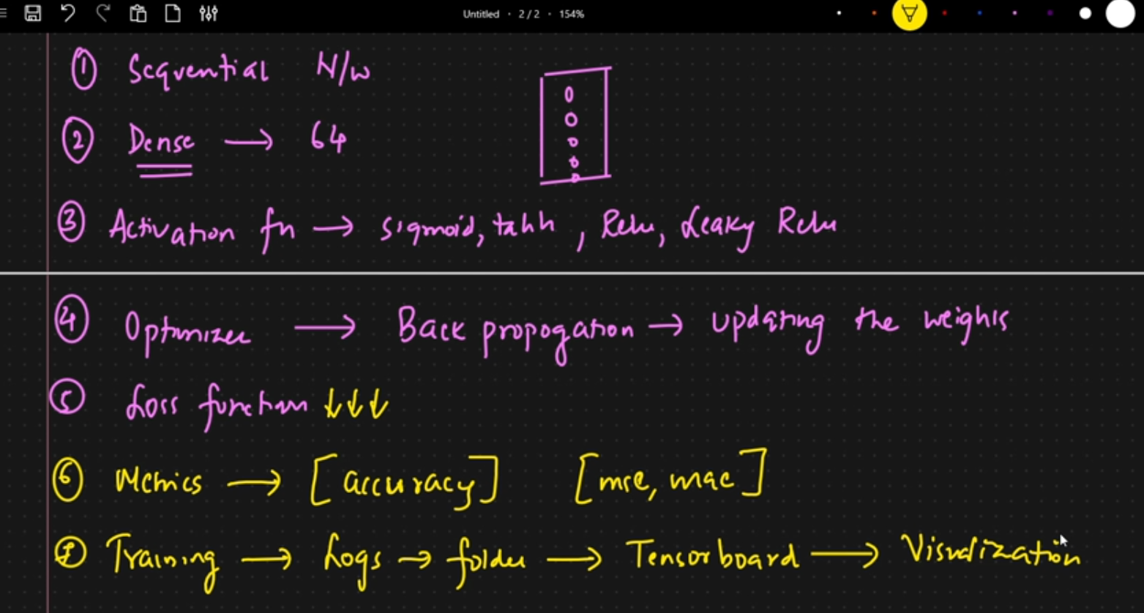

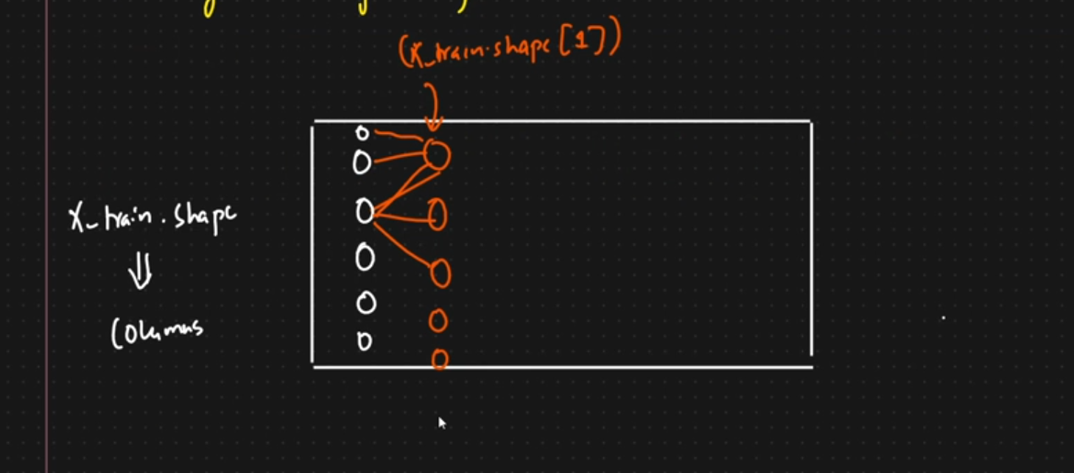
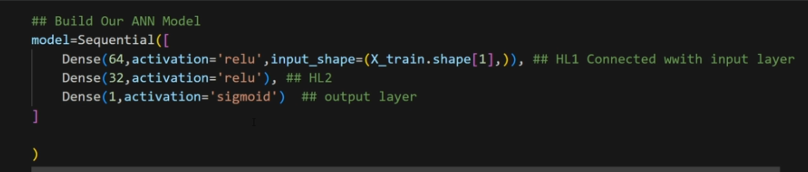
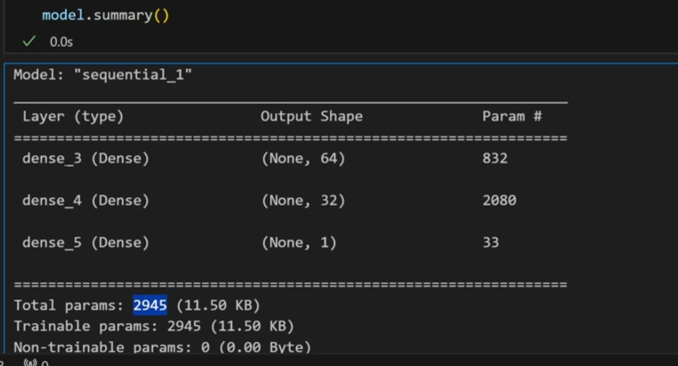
to do back ward propagation, compile the model
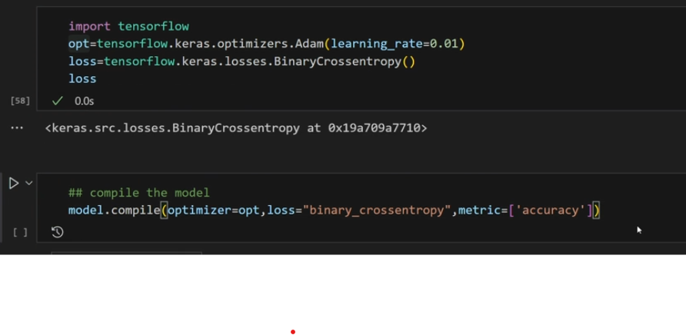
for the logs set up the tensor board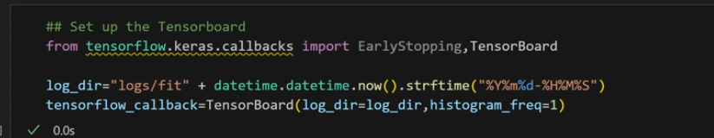
if the model has trained for 10 epochs instead of 100 epochs, use early stopping

train the model
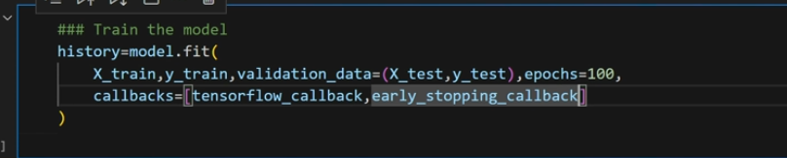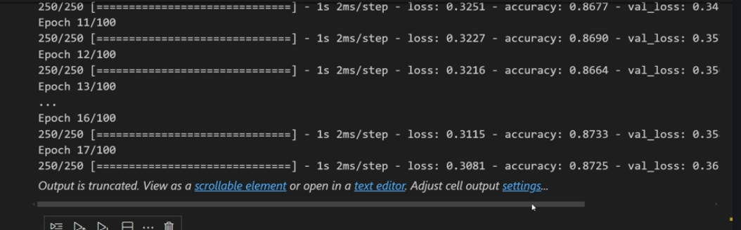

now save the model in h5 format, h5 format is compatible with Keras
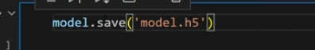

load tensor board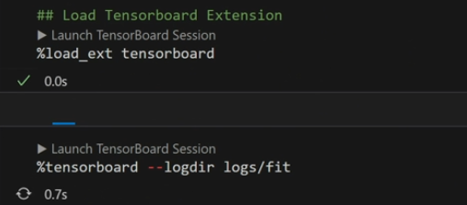
Tensor dashboard
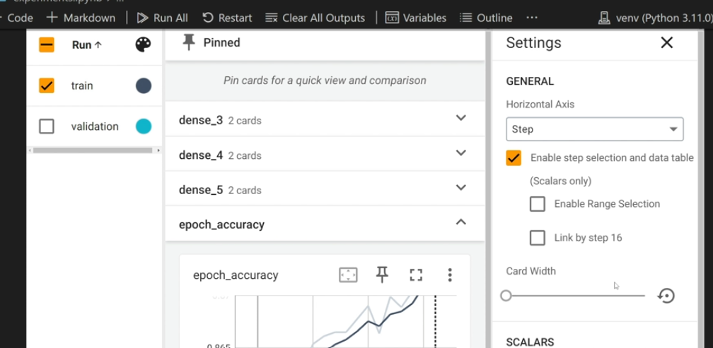

How do we load pickle file( pickle file is used to save complex python objects). Here we have 3 pickle files, one for Gender, one for Geography, and 3 one for complete data(scalar data)

Watch the file prediction.ipynb in the list how he is predicting the sample data.

Next is he created a streamlit app, where he created an UI for input data and used the model to predict the output. He deployed the app using the gitlink using streamlit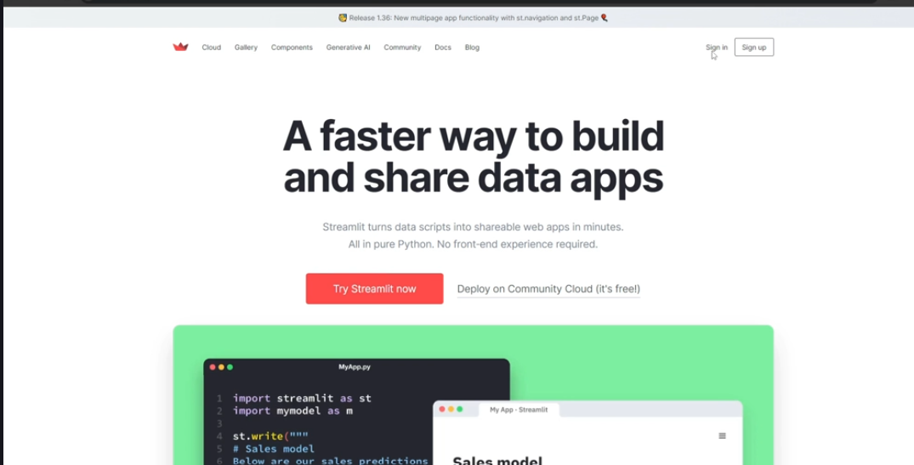

Next he created a new model that can predict the salary for the same dataset (Saleryregression.ipynb)
look into hyperparametertuningann.ipynb to understand how many hidden layers and hidden neurons are required in ANN.. he implemented it in code and showed.